

**Assignment : 01**

**Submitted by: Rehab Gul**

**Registration no:B23F0405AI126**

**Instructor : Sir Adnan**

**Department: BSAI Red**

**Date: 24th Sep ,2025**

**Group members: Rehab Gul, Umar Khan and Abdullah Aslam**

***Part 01 and 04:***

**Task 4:**

For the HTTP based website access, answer the following after analysing collected traces of HTTP:

**Question :01:**

What is the name of website?

**Answer:**

The name of the website is

**Host:** edgedl.me.gvt1.com

**Question :02:**

Find the packet that contains the first GET request for the website you have accessed.

**Answer:**

The packet that contains the first GET request for the website I have accessed is **packet 150**.

GET /edged1/diffgen-puffin/hfnkpimlhhgieaddgfemjhofmfb1lmnib/@d87d8674b1b70b3339



**Question :03:**

Describe all headers and their values in this GET request message.

**Answer:**

* **Host:** edged1.me.gvt1.com
* **Connection:** keep-alive
* **Upgrade-Insecure-Requests:** 1
* **User-Agent:** Microsoft BITS/7.8\r\n
* **Accept:** */*
* **Accept-Encoding:** identity
* **If-Unmodified-Since:** Sat, 20 Sep 2025 11:32:53 GMT
* **Range:** bytes=0-1119

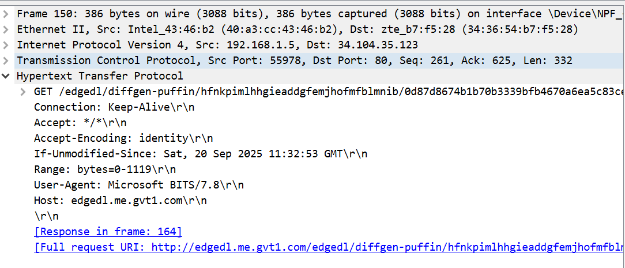

**Question :04:**

Identify the status code in the first server response.

**Answer:**

The status code : *200 OK"*.

HTTP/1.1 200 OK



**Question :05:**

How many HTTP response messages are exchanged in total?

**Answer:**

There are the 11 response Messages .

1. Packet 135: HTTP/1.1 200 OK (Response to the HEAD request)
2. Packet 144: HTTP/1.1 200 OK (Response to the GET request)
3. Packet 158: HTTP/1.1 206 Partial Content (Response to a GET request)
4. Packet 614: HTTP/1.1 206 Partial Content (Response to a GET request)
5. Packet 616: HTTP/1.1 206 Partial Content (Response to a GET request)
6. Packet 631: HTTP/1.1 206 Partial Content (Response to a GET request)
7. Packet 633: HTTP/1.1 206 Partial Content (Response to a GET request)
8. Packet 643: HTTP/1.1 206 Partial Content (Response to a GET request)
9. Packet 644: HTTP/1.1 206 Partial Content (Response to a GET request)
10. Packet 652: HTTP/1.1 206 Partial Content (Response to a GET request)
11. Packet 664: HTTP/1.1 206 Partial Content (Response to a GET request)

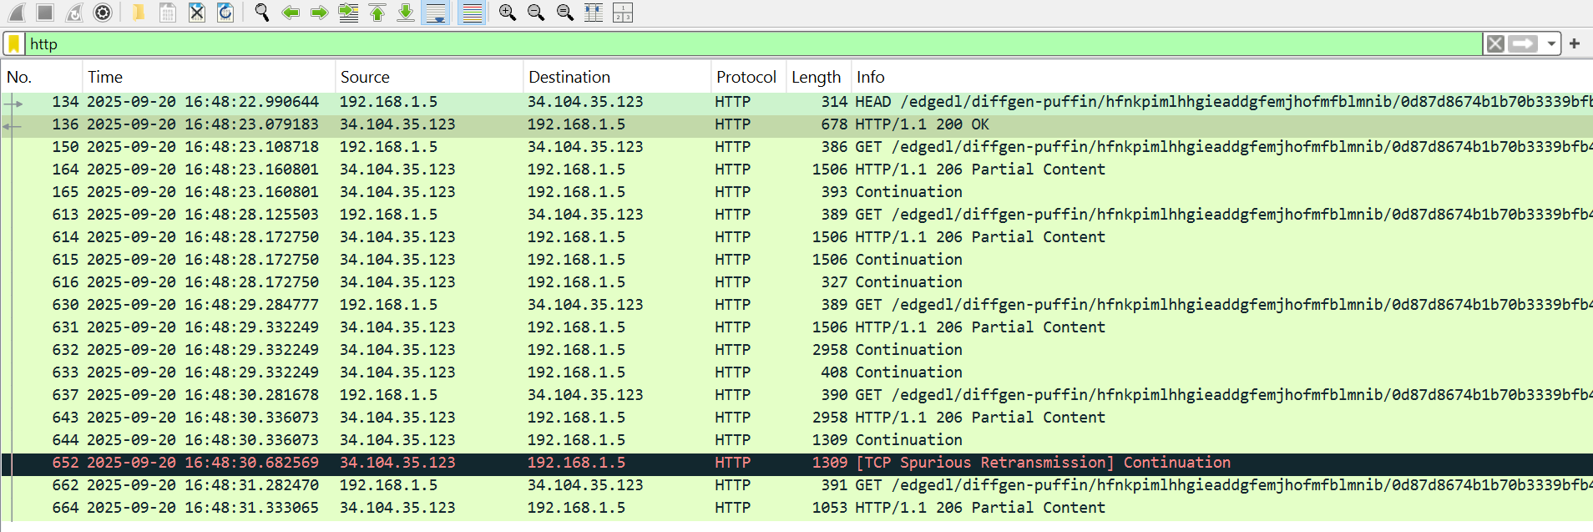

**Question :06:**

Determine whether the connection is persistent or not. Justify with evidence from packet captures.

**Answer:**

**Yes, the connection is persistent.**There is clear evidence in the capture:

1. **Client Request:** The client explicitly asks for a persistent connection with the header Connection : **Keep-Alive.**

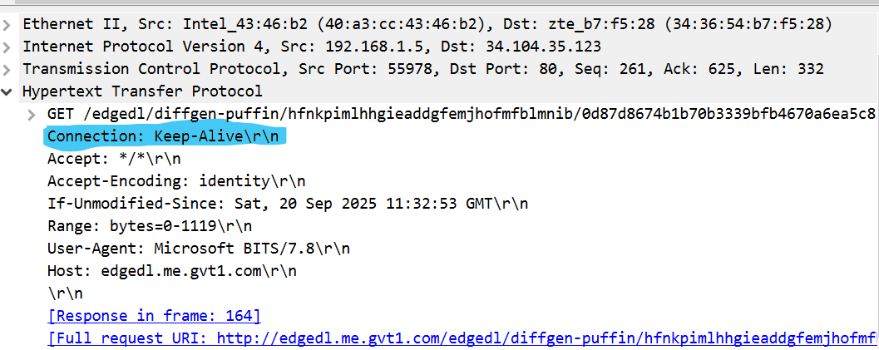

1. **Server Action:** Multiple HTTP request/response transactions (e.g., the GET requests in packets 150, 164, 165) occur between the same IP addresses (**192.168.1.5** and **34.104.35.123**) over a very short time span (~7 seconds) without the TCP connection being torn down and re-established between them. This is the practical evidence of a persistent connection being used.

The use of the **Range** header and multiple **206 Partial Content** responses is a classic example of a single client using a single persistent connection to download different chunks of a file.